[](https://www.google.com/url?sa=i&url=https://www.autism.org.uk/services/nas-schools/robert-ogden/learning/maths.aspx&psig=AOvVaw3FDBklwwz1avAvMlLGd_tm&ust=1592564984870000&source=images&cd=vfe&ved=0CAIQjRxqFwoTCPDJtpOdi-oCFQAAAAAdAAAAABAD)

**The Maths department is looking forward to welcoming you into your new school this September.**

**Here is a taster of all the new and exciting things you will be learning at your new school!**

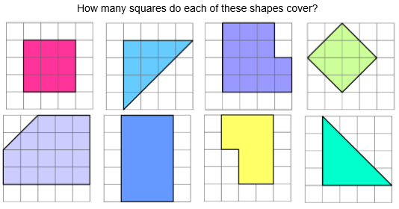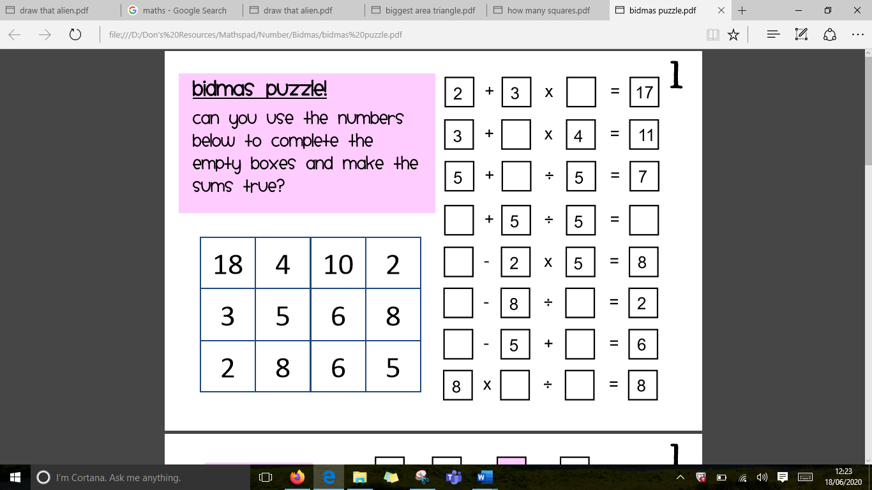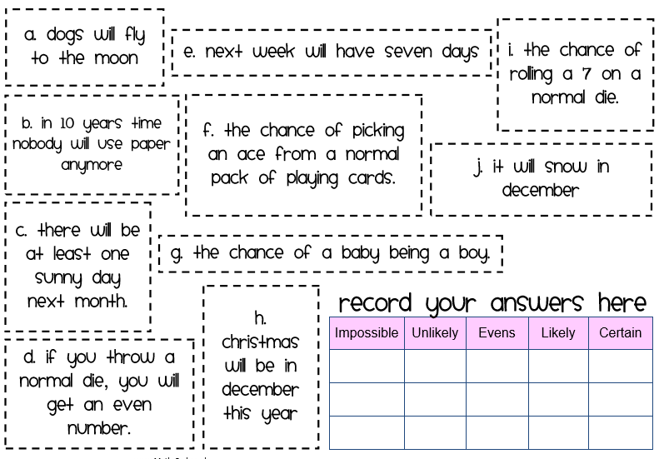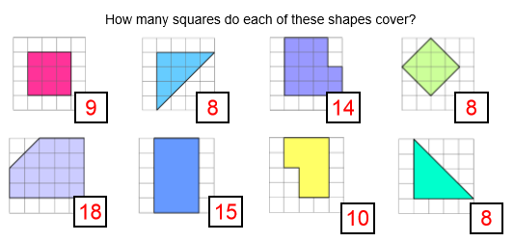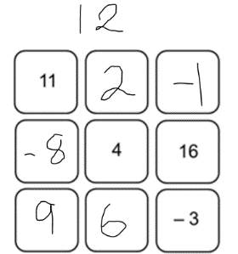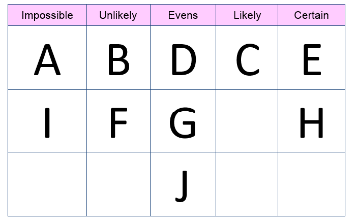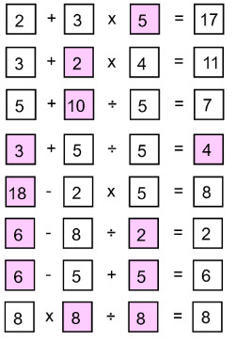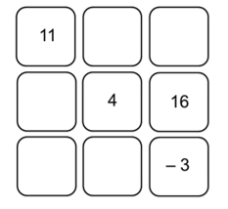

4

**Complete the magic squares so they have the same row, column and diagonal totals.**

3